Simon SQL queries:¨

1.



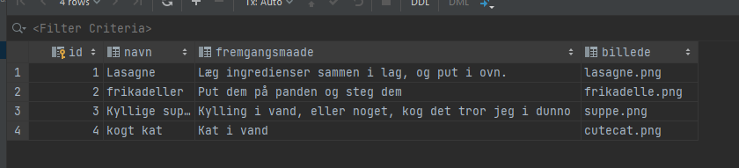

2.

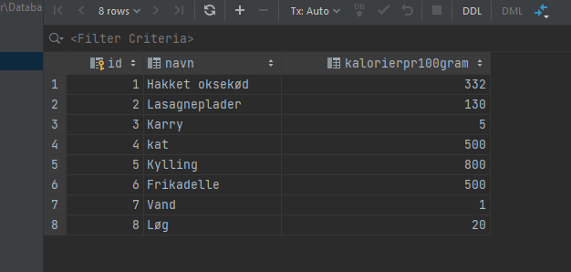

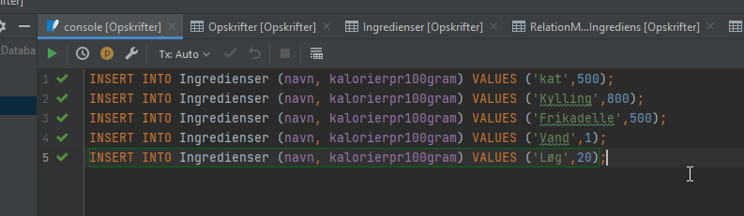

3.

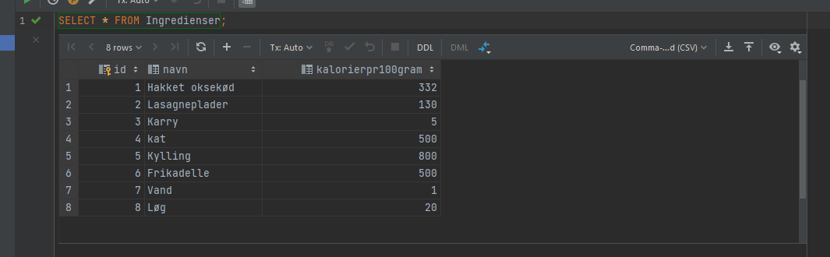

4.





5.



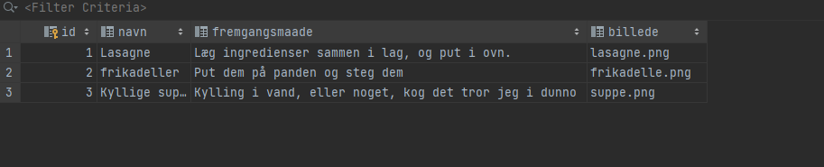

6.

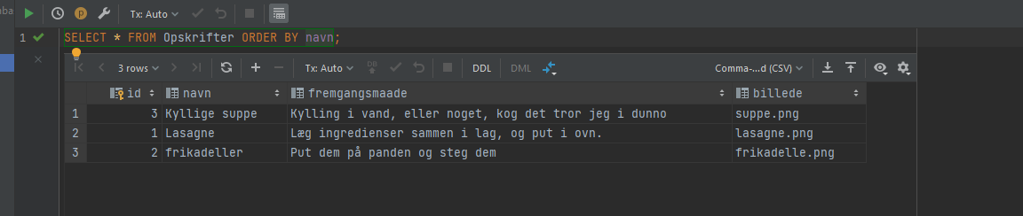

7.

